A response to the audit of
Global Grant 1525855 – Teacher Training, Tatopani, Nepal
by Rtn Peter Hall, President, Quality Education Nepal Inc.
endorsed by:
PP Dr. Kym Stock, Project Manager for International Sponsor RC Portland
23 July 2020
This report is addressed to Winson Mathew, Coordinator Stewardship, Rotary International South Asia Office who on 2 June 2020 addressed a letter sharing the results of the audit with Rtn K. B. Shahi, Project Manager for Host Sponsor RC Baglung. Winson has subsequently coordinated the responses required of the Host Sponsor.
Others associated with the conduct of the audit were:
- Anilkumar Shah, Auditor
- Rajiv Anand, Supervisor, Stewardship & Legal, RI South Asia Office (Winson’s superior) who accompanied Anil on the audit
- Christian Pepera, Senior Supervisor of The Rotary Foundation's Cadre of Technical Advisers who appointed Auditor Shah to his role
I address the issue as President of Quality Education Nepal (QEN), the Facilitating Organisation for GG1525855. That is not a role recognised by TRF, but it included assembling the funding, developing the budget (in collaboration with LEARN), writing the application, securing the commitment of RCs Portland and Baglung as International and Host Sponsor respectively, and drafting the MoU. That MoU, signed by the Presidents of those clubs and Krishna Pun, CEO of LEARN, became the legal agreement for LEARN's provision of services.
Please note that as the primary source of LEARN's funding and the underwriter of its existence, QEN has the right to dictate its expenditures, including any requested refunds to Rotary.
While I had no formal role in GG1525855 after the transfer of responsibility to the sponsor clubs, I maintained oversight and assisted where I was able to. That assistance was hampered by Regional Grants Officer Laura Bradley concluding that QEN was a Cooperating Organisation with a potential conflict of interest, and therefore to be excluded from copies of project correspondence - an attitude subsequently adopted by Rajesh and Anil in the conduct of the audit, to its clear detriment.
I stress that as Quality Education Nepal is registered project 43/2009-10 of Rotary Australia World Community Service, it has no such conflict of interest. Indeed, TRF and RAWCS entities should be able to work collaboratively together on an initiative such as this.
The total exclusion of the International sponsor from the audit process has likewise contributed to an unsatisfactory outcome - an exclusion that I cannot comprehend.
Financial management of the project
International Sponsor RC Portland, LEARN and QEN collectively reject the findings of the recent audit of the project with respect to Financial Management as outlined in your letter to KB Shahi dated 2 June.
At issue was the nature of the contract between LEARN and the sponsor clubs. Clause 7 of the MoU stated: LEARN SHALL: A. agree to deliver the services described as Activities in the grant application at the costs defined in the Budget section of that application,
The auditor chose to interpret this as saying at the costs incurred to a maximum of the costs defined in the Budget section of that application, an interpretation based upon the Foundation’s normal practice for Global Grants. Either that, or he chose to simply ignore the MoU maintaining as he did when we discussed the matter. We do not know, as we - RC Portland, LEARN and QEN - have been denied access to his report.
His conclusions imply an assumption that Rotary is above the law - that internal rules of TRF can over-ride a legal document such as the MoU, the only legal document to which LEARN was committed. I have consulted a Professor of Transnational Commercial Law at the University of Western Australia on the matter. Needless to say, he supported my position.
As the MoU clearly identified a fixed price contract, we reject all of your efforts to treat it as a cost-reimbursement contract. All of your attempts to recover monies from LEARN have been based on a false premise.
Before going into details, I wish to point out that KB and Krishna are Nepalis with very strong commitments of service to their communities, particularly in the area of education. On the other hand, they are naive in dealing with a large organisation like TRF or in running a business organisation like LEARN. I have therefore seen it as my role to provide mentoring to support them in their respective roles.
KB and Krishna operated throughout the project in accordance with the MoU, LEARN invoicing at the budget figures, and RC Baglung accepting and paying those invoices. Only after the audit did KB Shahi feel compelled to support a cost reimbursement basis of compensation. He accepted this as a consequence of your pressure upon him, against the strong and repeated advice of the International Sponsor.
As a result of the audit, KB and Krishna found themselves in very difficult circumstances. Krishna's role was to deliver the service, which Auditor Anil concluded he had done most effectively; and to secure payment from RC Baglung in accordance with the MoU. To combat the arguments of KB Shahi I have repeatedly emphasised to him that it was a fixed price contract.
Kym Stock repeated that message to KB, as he did in subsequent correspondence with you. While you have acknowledged receipt, you advised on 10 June: "Thank you for your follow-up e-mail. We are in the process of reviewing the response and will revert back to you".
Despite this, there has been no change in your efforts to secure the refund from LEARN of the difference between funds received and direct expenditures as disclosed by LEARN to the auditor in February.
I advised the auditor by email on 11 March that those expenditures did not represent the full costs of project delivery, as they did not include the cost of LEARN staff time committed. As Kym noted, LEARN had no system for recording this. The extent of those costs has yet to be determined (which I am addressing), so it is still unknown whether total project costs were greater or less than the agreed fixed prices.
The insistence of you and your colleagues upon payments to LEARN being limited to reimbursement of costs incurred, rather than agreed fixed prices, imposed upon KB Shahi an intolerable dilemma - how to comply with his club's legal obligations to pay LEARN as invoiced, reinforced by both myself and the International Sponsor, and the pressure you brought to bear to ignore the legal contract in favour of payments on an expenditure reimbursement basis.
Responses to your demands
Krishna has referred to me copies of emails you sent to KB on 14 and 15 July together with RC_Baglung_GG1525855.docx, KB's response to you on 14 July. In it he refers to a request to LEARN to refund NPR 1,123,417.00 (US$9,370) as a deposit to the RC Baglung bank Account. That correspondence is misleading as to the real situation, which I must therefore document:
1. In your letter to KB of 3 June advising the outcome of the audit, you demanded submission of a bank statement confirming deposit of surplus funds NPR 784,640 (US$ 6,540) back to project bank account.
2. As I had instructed LEARN not to refund any monies to the project, such a deposit could not come from LEARN. As Krishna was keen to achieve a consensual outcome with KB, he arranged a deposit from another source. The deposit was made on 28 June.
3. On 29 June KB responded with a matching payment back to LEARN. The reason for this payment was ostensibly additional LEARN expenditure:
- 12,200 travel expenses incurred by Krishna in the conduct of the audit
- 50,000 for the services of an auditor engaged by RC Baglung
- 582,440 for the provision of additional school materials to be supplied.
I address the actual dispersal of that 784,640 in point 8 below.
4. On 30 June, KB paid LEARN an additional NPR 1,179,000 (US$ 9.825). This was ostensibly to cover:
- 399,400 for equipment for 20 Early Childhood Education and Development (ECED) centres
- 699,993 for computer laptops for 14 schools
- 29,800 for materials transportation
- 49,833 for Rotary signage to be offered to the schools that had benefited from the training.
Apart from the signage, none of these expenses had been incurred.
It was not a coincidence that the sum of 1,179,000 matched LEARN's invoice XIII which remained unpaid.
5. On 15 July KB sent you a document informing you that he had submitted to LEARN a request for NPR 1,234,417 (US 10,289) to be deposited in the RC Baglung bank account. The derivation of that figure, contained in his table, is not apparent.
6. LEARN will not make this payment as, on behalf of QEN, I have reasserted the instruction not to do so.
7. LEARN will accept the payment of NPR 1,179,000 on 30 June as payment in full of Invoice XIII.
8. Of the payment of NPR 784,640 received on 29 June, LEARN will attribute:
- 147,000 to payment in full of Invoice XII
- 12,200 to reimbursement of travel costs incurred by Krishna in the conduct of the audit
- 55,750 to reimbursement of payment by LEARN for the services of an auditor engaged by RC Baglung. This was the 50,000 noted above plus 13% tax.
The latter two payments related to the audit and not the project, and therefore should be borne by TRF.
9. I have instructed LEARN to refund the balance of 569,690 to RC Baglung. Krishna Pun will initiate that payment when he is satisfied that our issues of disagreement have been resolved.
10. I draw your attention to the failure of the auditor to ensure that all donor contributions to the project had been received. Six Nepalese clubs each committed US$100. The DRFC for D3292 at the time delayed his approval of the application until he had confirmation of these commitments. They remain unfulfilled.
11. I note the minutes of a Board meeting of RC Baglung on 18 July attended remotely by PDG Kiran Shrestha instructed the Cooperative Organization Organization LEARN by letter that funds paid for a remaining program of material supply of ECED and ICT at a cost of Rs.1,123,417 be refunded to the Rotary Club of Baglung. This reflects point 5 above. QEN’s response remains unchanged.
Rotary Awareness and Signage
I note your comments regarding Rotary Awareness and Signage and your requirement to submit photographs to confirm that Rotary signage is updated on project site / beneficiary schools as per Rotary International’s Policy.
Rotary funding of the project was acknowledged in banners displayed at the Opening and Closing Ceremonies of every course:
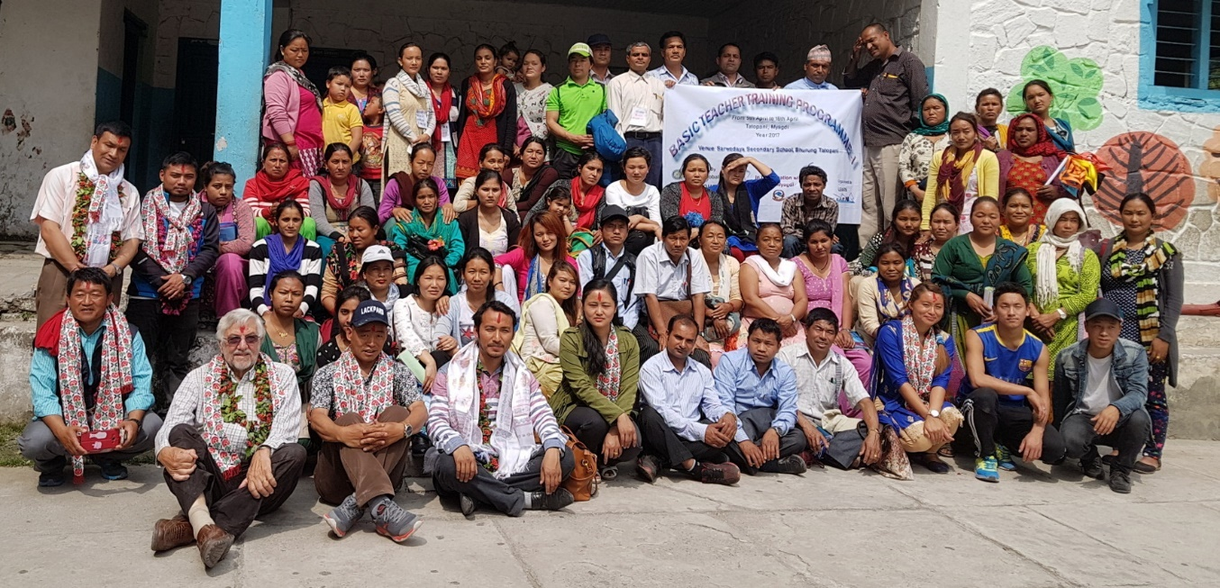
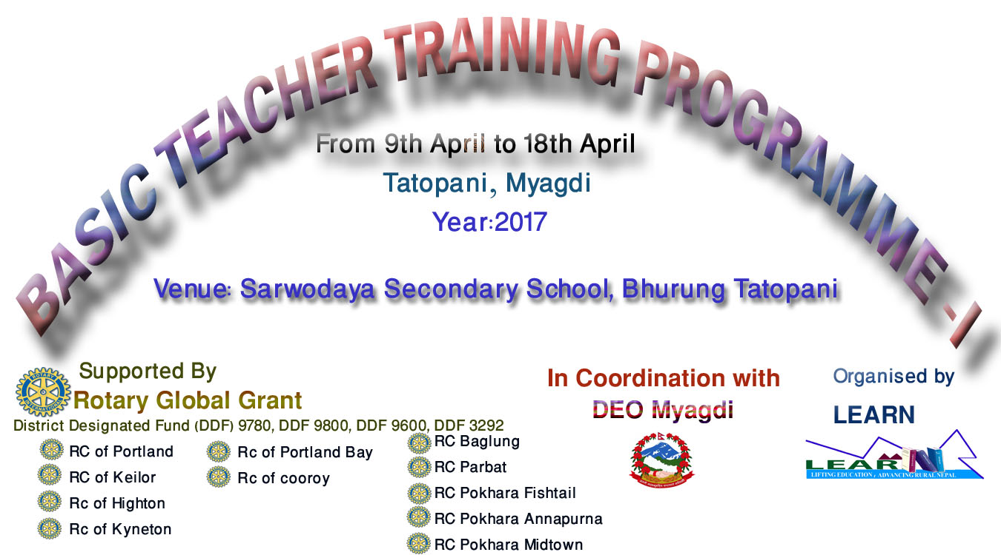
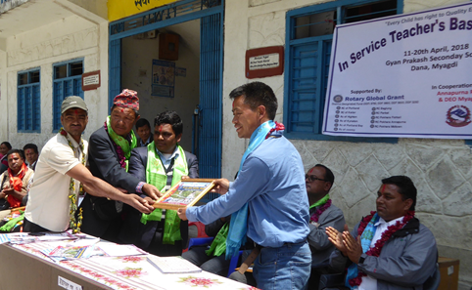
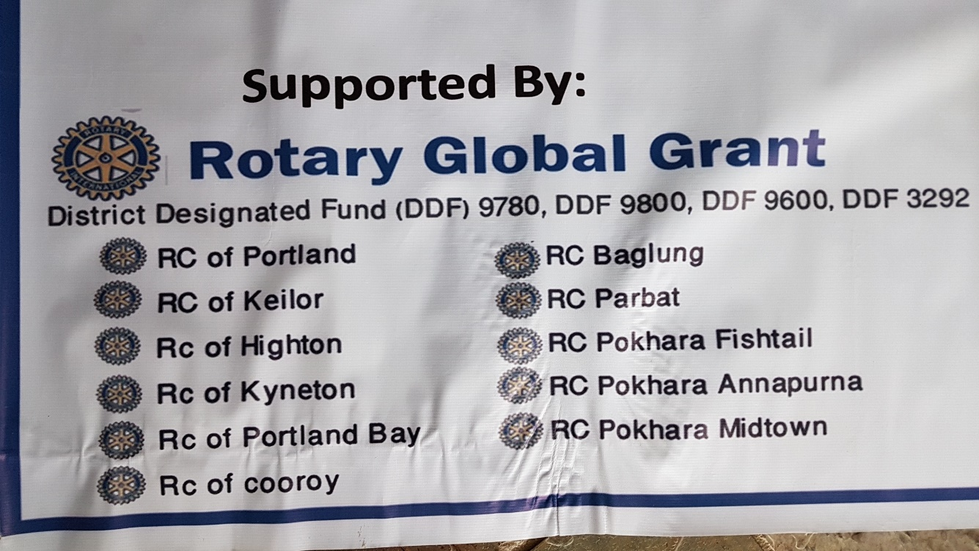
Please note that these signs acknowledge not only the Global Grant and the sponsorships of RC Portland and RC Baglung, but also the commitments of other Australian and Nepalese clubs. Accidentally omitted from the clubs listed were RCs Keilor East, Gympie, Gympie-Cooloola and Lekhnath.
As noted in my point 10 above, the Nepalese club contributions, while acknowledged, were never received.
I do not consider it appropriate to expect the schools to add to the display of signage at the courses by the display of permanent signage. On the other hand, I note the impressive plaques that KB Shahi has designed to comply with your request.

The plaques have been prepared and will be offered to the schools, but on the condition that if they are to be placed on permanent display they must be accompanied by a matching sign that puts the three-year program in context. These have yet to be designed, but their message will be:
"Training in the Global Grant project was delivered by LEARN, an NGO established in 2014 under the auspices of Quality Education Nepal Inc., Australia. All subsequent support in the form of school supplies, in-school support and annual refresher training will be funded by QEN, as Rotary Foundation rules preclude continuing funding to the same beneficiaries.
59 Rotary Clubs from eight countries offered funds to extend similar programs to Rakhu and Pakhapani school clusters, but The Rotary Foundation declined to support them and other similar programs that might have followed in the future.
That training is instead being funded by Quality Education Nepal, continuing its efforts to extend Quality Education throughout Myagdi District."

Conclusion
As far as RC Portland, LEARN and QEN are concerned, this represents the conclusion of a successful project. To quote your letter of 2 June:
"After reviewing the audit report, The Rotary Foundation (TRF) was pleased to note the following:
- An effective community assessment was conducted by the cooperating organization, “LEARN”. In addition, they also carried out appropriate teachers training in remote areas.
- The beneficiary teachers were satisfied with the training/learning."
And in the words of the auditor in his email of 26 May:
"I congratulate all the concerned for correctly assessing the need of the society and completing the project as envisaged in the grant".
Postscript
Having just completed my draft of this report my inbox rang with an email from Krishna:
“I am under continuous pressure for refunding that fund to conduct the activities soon after the locked down. My humble request that let them do it. . . . I foresee further case will create bigger problems to all of us. Sometimes being defeated results winning in long run. I hope you would consider on it. There is no one in Nepal who understand you the best than me. I know you from my heart that what things you are doing is all for Nepali people but some people in Rotary are not seeing these.”
Kym Stock and I will not give in to the continuous pressure to which Krishna refers. It is a blatant attempt to enforce an illegal solution which neither I nor Kym will accept.
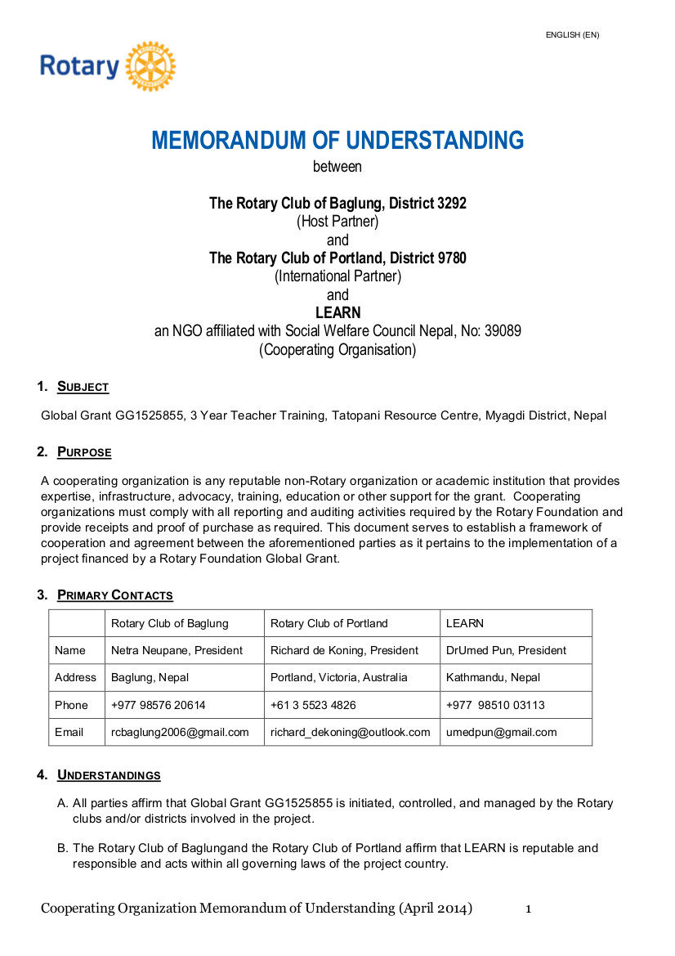
Appendix 1
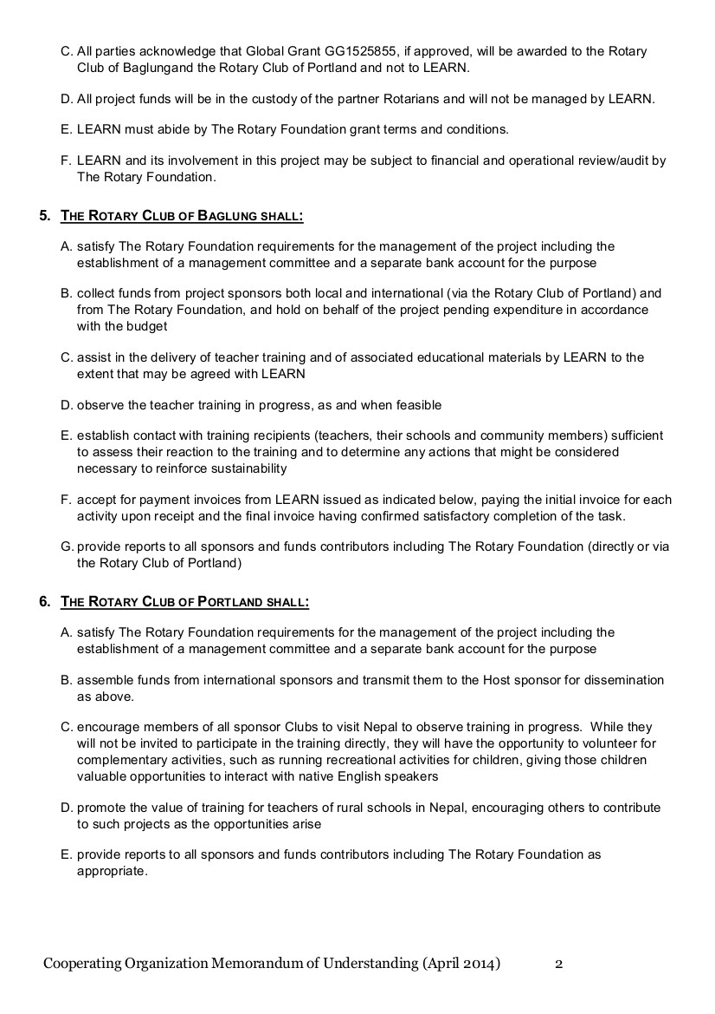

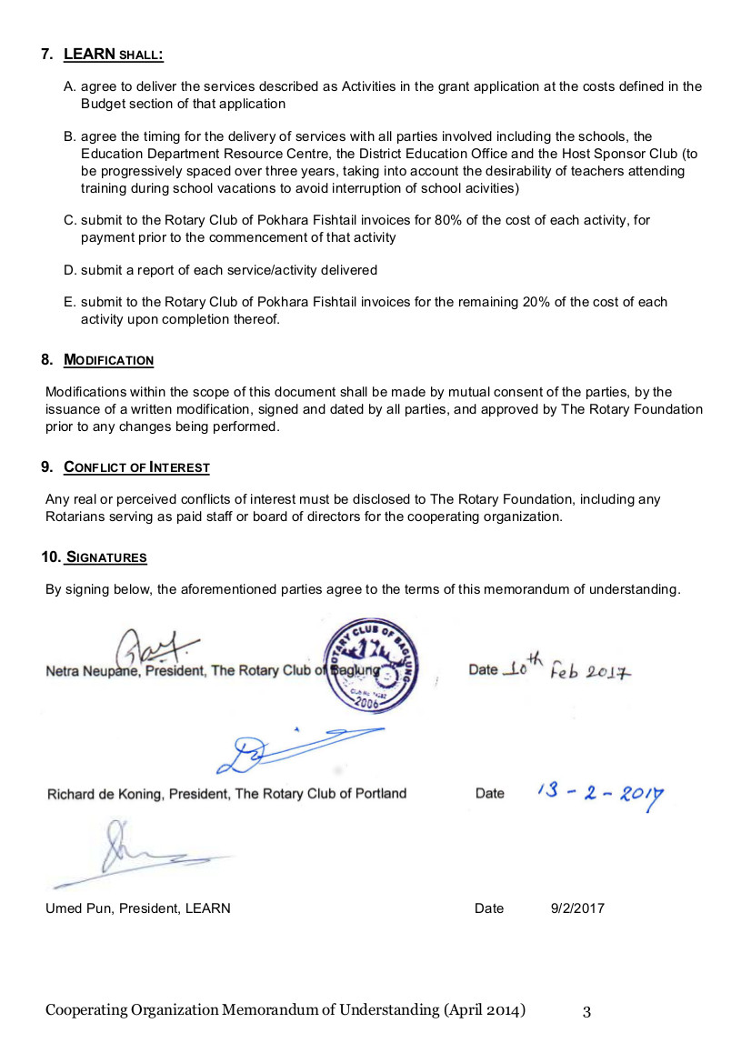

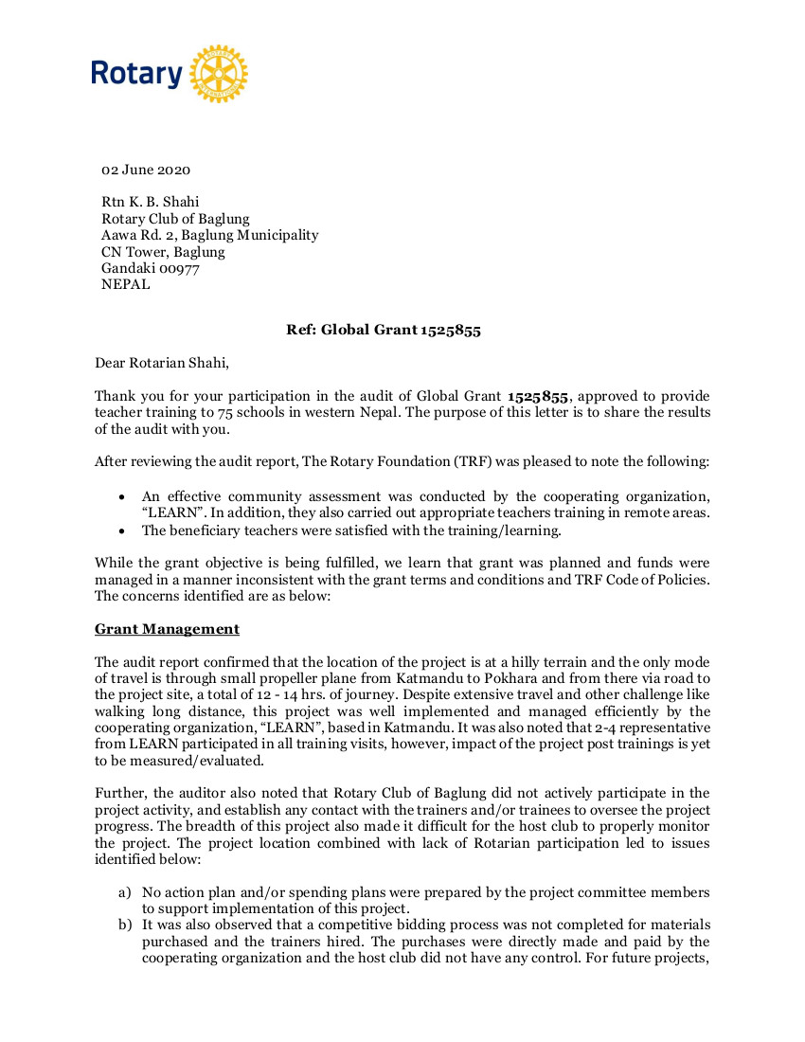
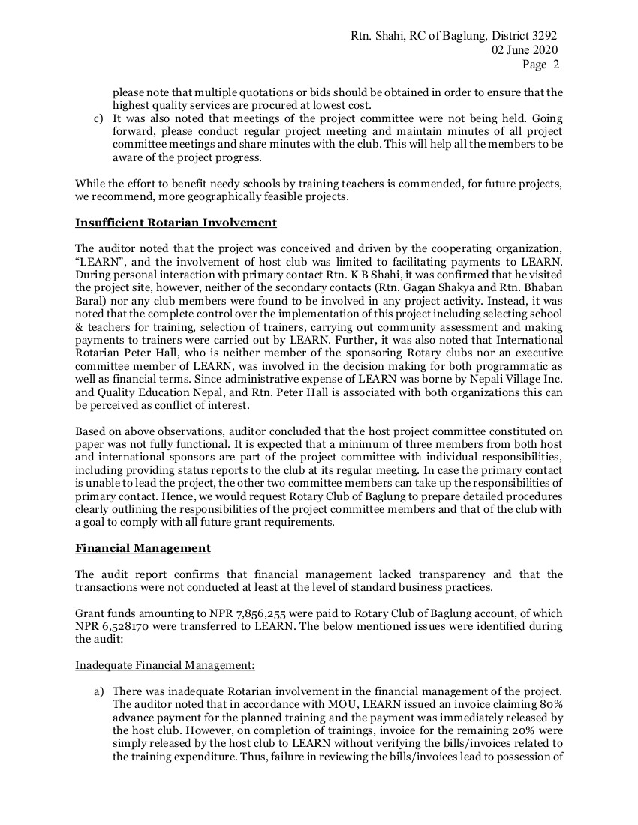
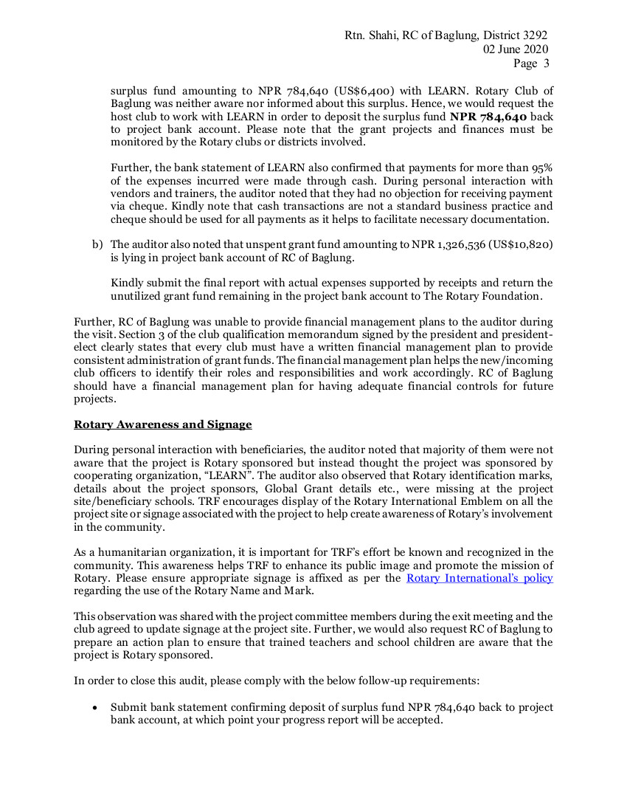
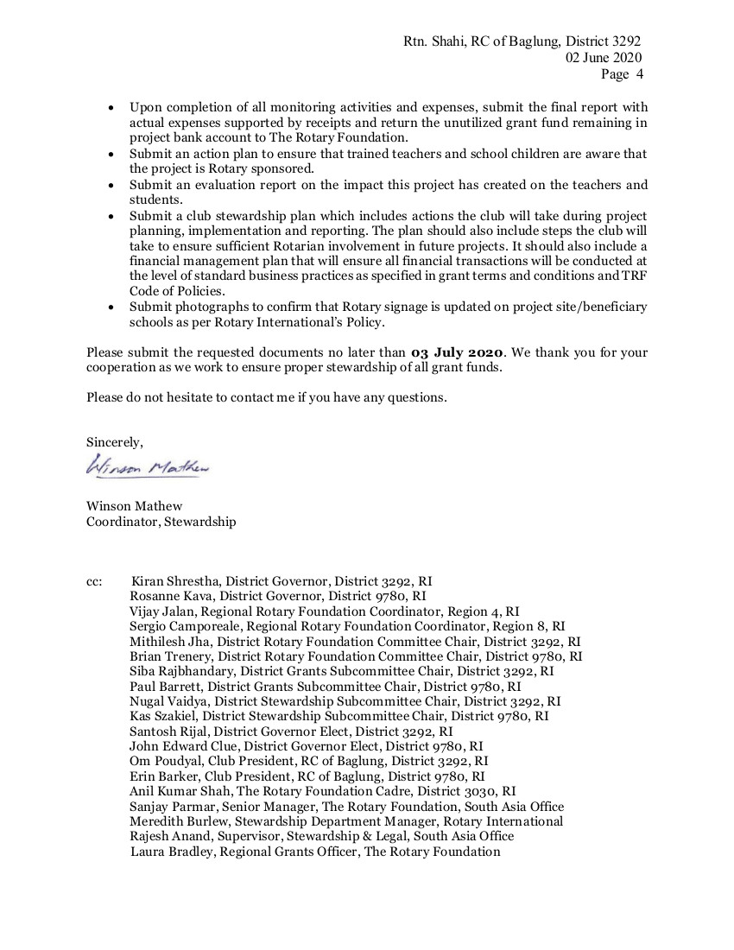

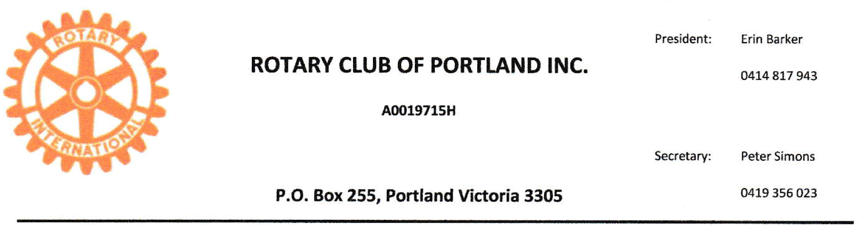
Winston Mathew
Coordinator Stewardship, TRF

6/6/2020

Dear Mr. Mathew,
I am in receipt of a copy of your letter to Rotarian K.B. Shahi dated 02/06/2020 concerning the GG 1525855 audit report, provided to me by my club President. I am head of the GG 1525855 International Club committee. As
project manager for the International Sponsor club I am surprised that I have been excluded from the audit
process. Had that not been the case, I believe I may have had the opportunity to correct the mistaken conclusions of the auditor.
I wish to point out some errors in the report letter, so that you can better understand the situation.
The problem arises with the audit process being based on the teacher training program being conducted on a cost basis, by Rotarians leading the program. Our application for the grant made it abundantly clear several times that this would not be the case and why it was impossible for Rotarians to deliver the training program.
The reasons are as follows;
1) We could not find Rotarians who had the qualifications to deliver the program.
2) We could not find Rotarians (qualified teacher trainers) who could speak, read and write in Nepali.
3) We could not afford to send training teams to Nepal for weeks at a time, every month for 3 years within the budget we could afford
For this reason our application stated that we would use the services of an appropriately trained NGO. (LEARN) team contracted on a fixed price budget to deliver the services. TRF accepted our application for a grant, but there was never any qualification that our proposed business model needed to be changed.
As you have been made aware, the area of great need for this program is extremely remote. The Rotary Club of Baglung members had challenges to verify service delivery often, because of the transport challenges. To suggest that they should seek projects closer to their base would surely deprive the more remote areas of rural Nepal even more than at present.
In my 50 years of being in business, a fixed price contract is just that; fixed price. You agree on a fee for service and pay the agreed amount upon receipt of services. There was no need to have spending plans or competitive bidding for materials used by the trainers. That was a matter for LEARN to manage.
With regard to competitive pricing for the hire of trainers to deliver the services in remote rural Nepal, I wish to point out that there is a dearth in supply of qualified teacher trainers in Nepal. The previous training program prior to the GG1525855 funded program was carried out by a team employed by the Australian Himalayan Foundation. That team was no longer willing to travel to the region. I understand that the fee paid for the RAWCS funded program was used to gauge a fair and reasonable fee for this project. That is about as close to competitive tendering as you will get in Nepal.
The matter of insufficient Rotary involvement also presumes that Rotarians were delivering the program. As stated we had engaged LEARN to provide these services and it would not be professional of us to interfere with their processes, unless we became aware of poor performance. Visits to the project by PP Margaret Wagner
primary level school headmistress) and several other Rotarian teachers (members RC of Portland Bay) reported in glowing terms of the changes in teaching delivery since the program commenced. 1 saw my group's role as collector of donations in Australia and reporting of project progress to TRF. Rotarian K.B. Shahi's group's role was in service verification and payment of invoices. Their (RC Baglung) Annual reports were shared with my club and other donor clubs.
Next I want to address the comments about Rotarian Peter Hall. Rotary has over the years advertised that it takes only one Rotarian to champion a cause, then others will join in with support and the Foundation will have a funding multiplier effect. That is how I view Peter Hall. His role in getting teacher training happening, establishing a support organization (QEN) and forming a NGO to fill the hole left by the exit of the Australian Himalayan Foundation training team has been pivotal to success. We have made extensive use of his contacts and local knowledge to expedite the program. Peter was a management consultant and is well versed in matters financial. Why would we not listen to his advice? To say he has a conflict in interest is an insult to Peter's integrity.
I noted you requested the RC of Baglung prepare detailed procedures / responsibilities of the project committee members etc. Why are these reports needed, seeing that the teacher training program is now completed?
I totally disagree with the alleged lack of transparency in the financial management and that transactions were not at the level of standard business practice. Nothing could be further from the truth. We have conducted the fixed price contract procedure along accepted business lines. LEARN issued an invoice for each stage of the
training for the agreed price, we paid the agreed amount and received a written receipt. Had TRF made it clear from the outset that they required an NGO to provide all financial details of their purchases and costs, perhaps this unfortunate situation could have been avoided?
To address the funds in the RC Baglung GG account, I wish to point out that the final invoice for services rendered by LEARN has yet to be paid. This is a legal requirement and must be paid to avoid breach of contract. The current balance of funds was paid directly by donor clubs, not via TRF and I have instructed KB Shahi not to comply for your request to send these funds to TRF, If there is any surplus after payment of the final invoice I will refund the donor clubs on a pro rate basis.
Signage acknowledging Rotary Funding was displayed at training course opening and closing ceremonies (see attached file). As ongoing in-school and refresher courses cannot be funded by Global Grant funds, we thought it inappropriate to erect permanent signage, possibly risking the appearance of contravening TRF rules.
I think it is a great pity that the project has been delivered on time and on budget, addressing recognized areas of need, yet inflexibility by TRF has left me feeling unsettled rather than proud of a collective achievement. This could have been one of many such programs that dragged Nepal out of poverty. We have pioneered a way to get the job done, why is TRF obstructing us rather than facilitating the project, over a matter of interpretation of the semantics in terms of a contract?
It is an opportunity to review how Rotary does business with other organizations in order to fill gaps in our areas of expertise and service delivery. In my opinion we can't demand other organizations abide by Rotary rules. In this case LEARN have tried very hard to assist. They lacked the staff time recording system that would have been necessary to determine the full costs of service delivery( a system they would have implemented had the contract been on a cost- recovery basis) Hence the surplus figure of NPR 784,640 quoted by the auditor has no validity.
In summary, I reject the audit report and call for a review by a higher authority. I will be sending my reply to all appropriate levels of District 9780 for their perusal.
Yours sincerely,
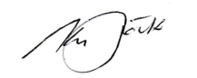

Dr Kym M Stock
Past President
Rotary Club of Portland
Victoria
Australia

Pressure tactics at work
Minutes of RC Baglung Board meeting attended by PDG Kirung Schrestha
demanding payment within 24 hours
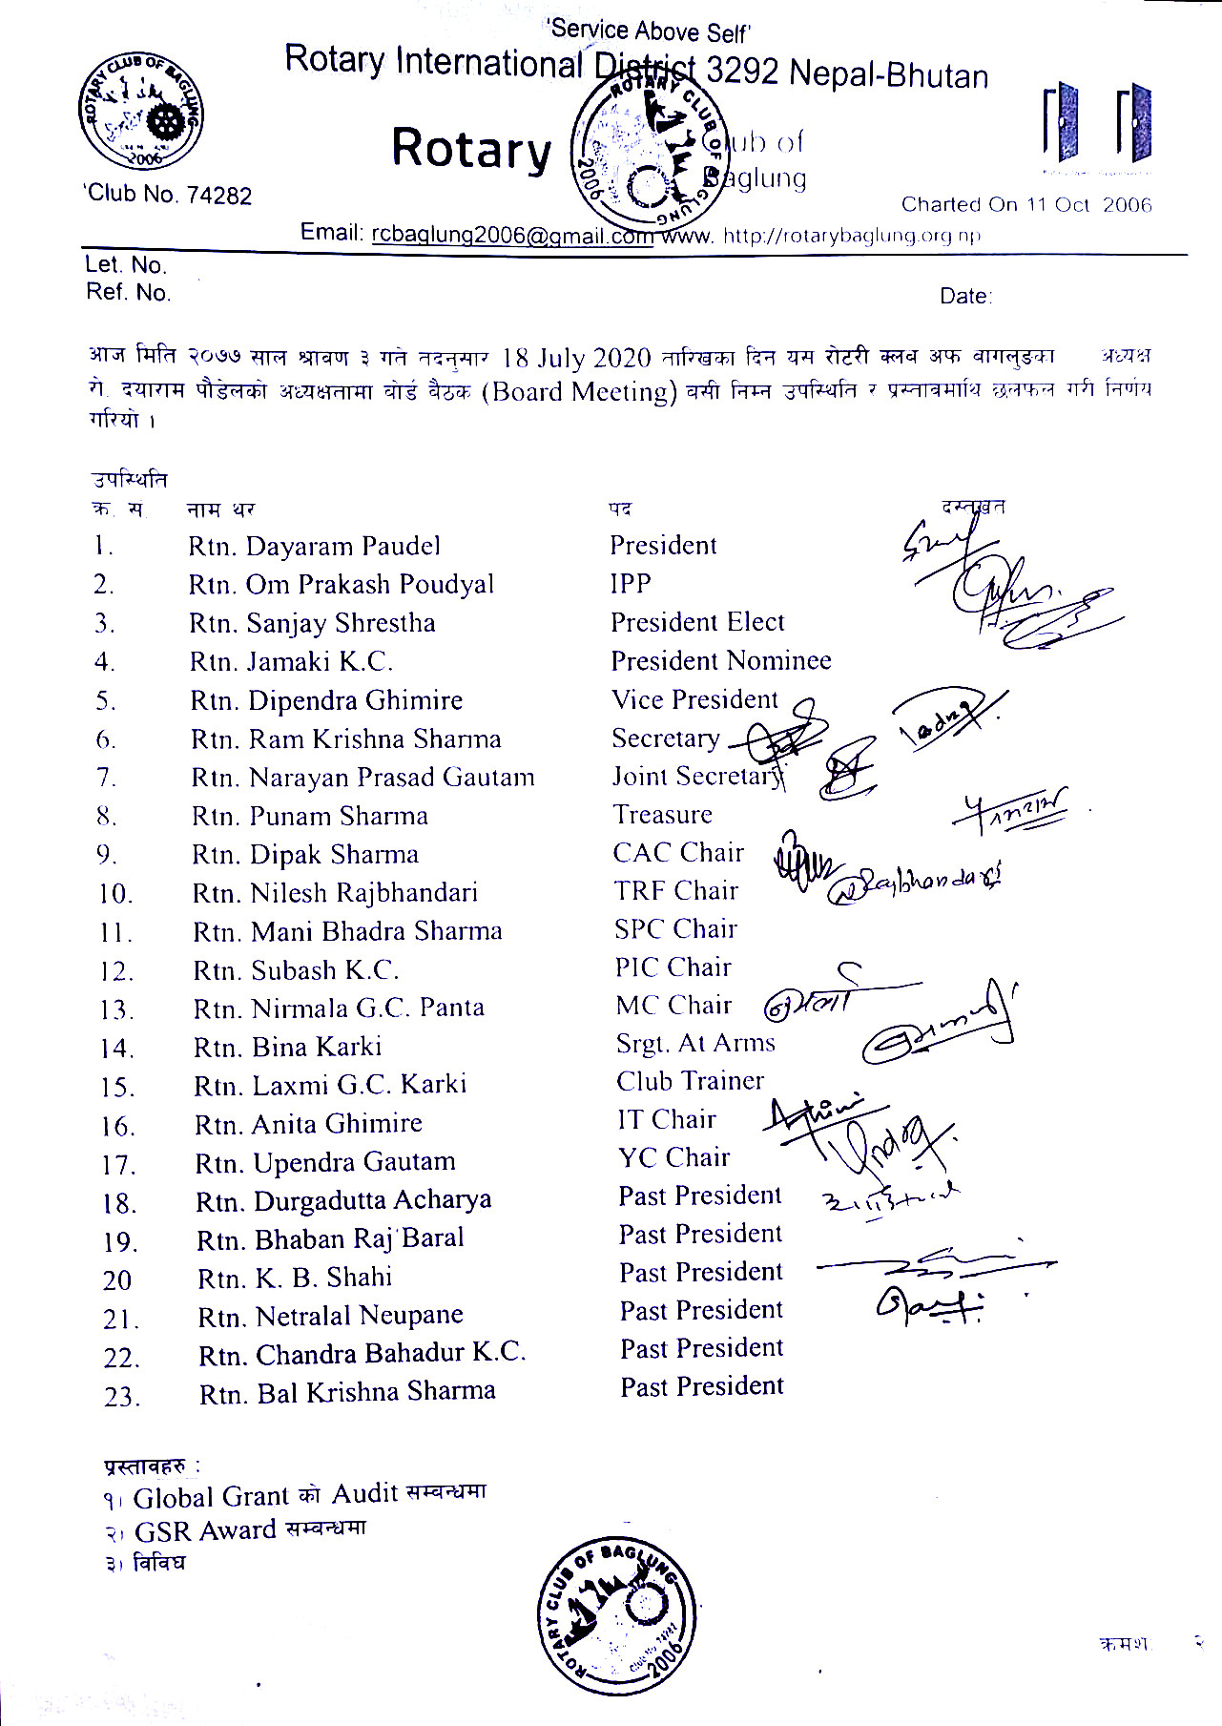
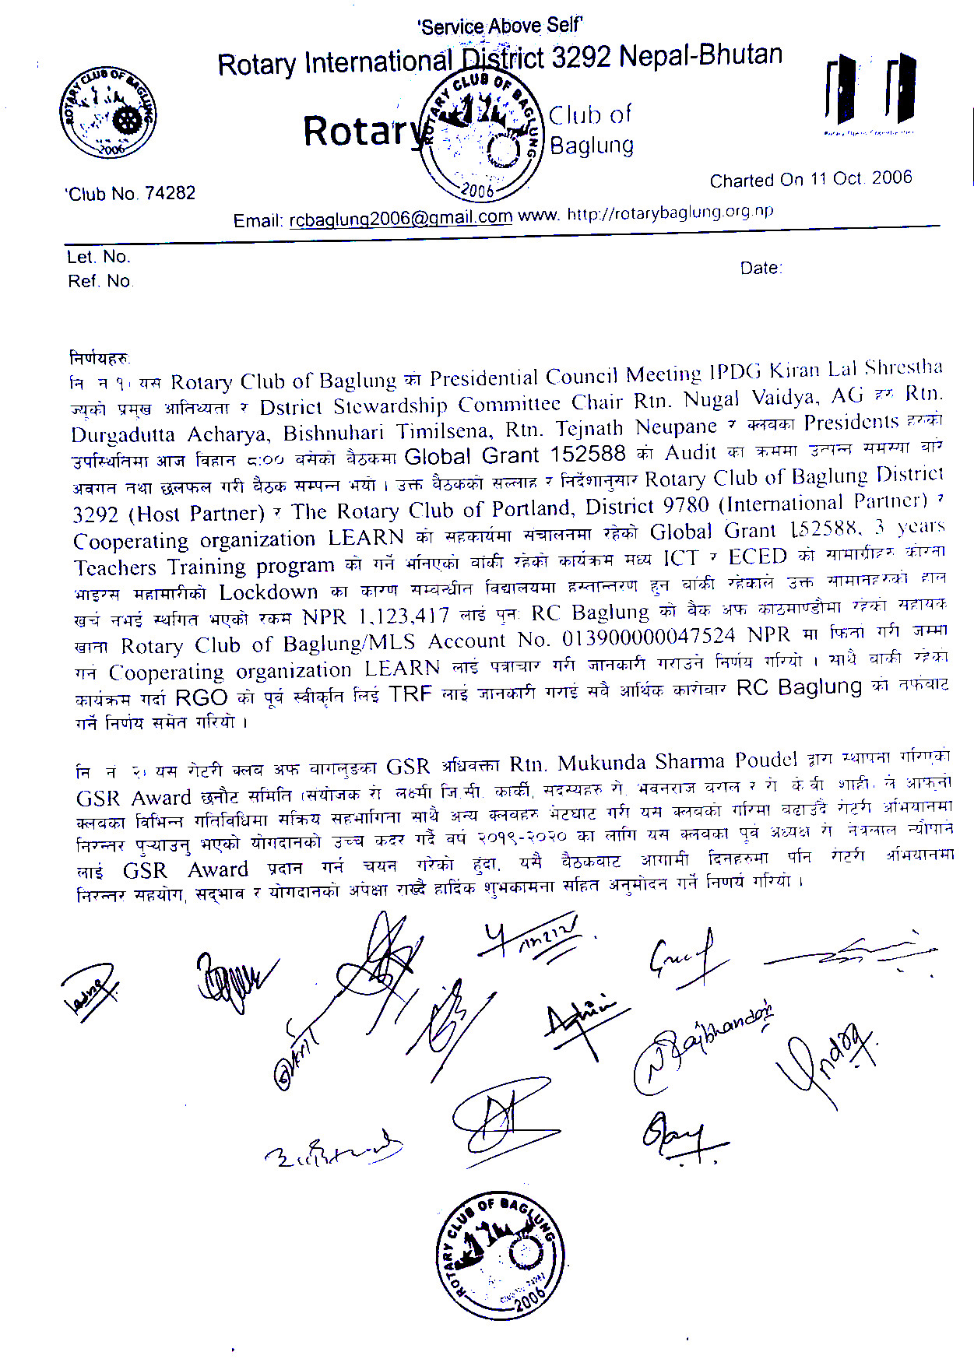

Translation
Rotary Club of Baglung
Time: 8:00 am
Today in 3 Shravan 2077 accordingly 18th July 2020, the Board Meeting of Rotary Club of Baglung is held in the presidency of President Dayaram Poudel. The meeting discussed the following agenda and decided accordingly.
Present:
…………………………….( list of present members and positions with signatures)…………………………….
Agenda;
- Global Grant Audit
- GSR Award
- Other

Meeting Decisions:
- The meeting of Presidential Council of Rotary Club of Baglung is held in the presence of Chief Guest IPDG Kiran Lal Shrestha, District Stewardship Committee Chair Nugal Vaidya, AG Durgadutta Acharya, Bishnu Hari Timilsena, Tej Nath Neupane and Club Presidents at 8:00 am. The meeting discussed on the issues raised in the auditing of the three-year teacher training program of Global Grant Project 152588 involving collaboration between the Rotary Club of Baglung District 3292 (Host Partner), the Rotary Club of Portland District 9780 (International Partner) and Cooperative Organization LEARN. The meeting suggests and instructs the Cooperative Organization LEARN by letter that funds paid for a remaining program of material supply of ECED and ICT at a cost of Rs.1,123,417 be refunded to the Rotary Club of Baglung/MLS account no. 013900000047524, Bank of Kathmandu Branch. The Rotary Club of Baglung will be responsible for all financial activities for this remaining programs. The Club should get pre-approval from the RGO [Rotary Grants Officer] and inform TRF.

- ……………………..( not relevant agenda)…………………

……………………………(signatures of members physically present)…………………………………

TRF’s Urgency in Context
Timing now seemed to be of critical importance to TRF, driving Project Manager Shahi to send, on 19 July, the above minutes of a Board meeting held on 18 July demanding payment on 20 July.
This was quite a change from the timeliness shown in this audit saga to date:
- On 15/8/19 Christian Pepera advised the sponsor clubs of an audit expected to take place in the first week of October. As no further correspondence had been received by the sponsors by that time, I advised PRIP Ian Riseley of the situation in an email addressing another matter. Two days later I received an apology from Christian advising delay. The audit did not take place until the last week of February this year – a delay of almost five months.
- Christian's initial advice was that a report to TRF would be due 14 days after completion of the audit. It was not completed until three months after the audit. The International Sponsor and the Cooperating Organisation have yet to receive copies of that report.
- A letter from Winson advising the outcome of the audit was received by International Sponsor Kym Stock on 4 June. He responded protesting the validity of the findings on 6 June. Winson responded on 10 June: "Thank you for your follow-up e-mail. We are in the process of reviewing the response and will revert back to you." Six weeks later that response is still awaited.
On the nominated date of 20 July I responded to Winson Mathew and KB Shahi making the above point, advising that I was emailing DG Rajiv Pokhrel seeking his advice.
Rather than awaiting that advice, the email barrage continued:
From KB Shahi to LEARN, 20/7:
“We are awaiting your deposit of refund unutilized grant fund NPR 1,123,417.00 to project bank account. As per TRF rules and Grade team kindly deposit the fund ASAP.”
From IPDG Kiran Lal Shrestha to KB Shahi, cc 9 others, 21/7:
Thanks for the information, Please note that TRF Grant should be spent according to previous approval and this is the money of
1.2 million Rotarian, So excess amount must send back to TRF or can be spent only with the approval of TRF. So it's better to send back money to TRF and than Your club track records will be fine otherwise you will be not eligible for applying for a grant in future and all the concerned parties will be blacklisted as well as our Dist. 3292 and all.
So This is a very serious matter for all of us, Please ask Learn Nepal to deposit back to RC Banglung account ASAP because i am getting several calls from TRF to solve this issue.
Hope you will all understand my position and corporate all of us.
From Krishna Pun to Kym Stock and myself, 21/7:
“I am prepared to return the amount to RC Baglung today though I am sure you suggest not to do so. I am not being able to sleep several nights. I can’t hold this tension any more. This is leading to shut down LEARN more than this is I am going in depression.
I am sure no one from Rotary officials will respond you nor read the document you have sent them. A lot of Nepali clubs are getting angry as the club programs are stuck due to RGG 152588. District 3292 is angry and emerging us to do it right now. Everyone is pushing us more strictly. I am not being able even to answer them and think widely. I have felt so burden to have this project.
After having fighting with Rotary, we gain nothing and this is 100% that we will not have any connection and work further in future anyway. Please calm down to end this subject. Could keep on claiming from the side of international club”
From KB Shahi to LEARN, 23/7:
“We are awaiting for your reply for deposit the RGG 152588 unspent grant fund NPR 1,123,417.00 back to project bank account of RC of Baglung. Kindly deposit the unspent grant fund ASAP.”.
The LEARN Board finally succumbed to the pressure that had been brought to bear, agreeing to refund the amount to Rotary club of Baglung. This decision was taken without acknowledging the validity of their claim.
On the same day DG Pokhrel responded to my request for his advice:
“I am not very aware of this project and do not know the details as it was not referred to me earlier.
However from the little that I know I believe an audit was conducted by the Rotary Foundation and they have suggested that whatever remaining money needs to be returned.
As I am very occupied with my responsibilities as DG I will not be able to attend every matter on this. Please correspond with the foundation office and do the needful.”.

